Template and instructions
First A. Author*¹, Second B. Author2 and Third C. Author3

^{1, 2} Authors’ Department, Institute, Organisation, Country
(E-mail: firstauthorsname@aaaa.bbb, secondauthorsname@aaaa.bbb)
³ Author’s Department, Institute, Organisation, Country
(E-mail: thirdauthorsname@aaaa.bbb)

ABSTRACT – This is the template and instructions for papers to submit ISNET’2025. Authors are advised to read carefully and follow this guideline.
Keywords: One; two; three
- INTRODUCTION
The paper should be no more than 2 pages long, including figures, tables and references, and should be written entirely in English.
The paper should explain the aim and scope of your study, the materials and methods used, the results obtained, and the main conclusions reached in separate titles as usual.
- FORMAT
The structure of the extended abstract should be:
- Abstract (65 – 100 words)
- Keywords (3 – 5 keywords)
- 1. Introduction (140 – 180 words)
- 2. Material and Methods
- 3. Results and Discussion
- 4. Conclusions (70 – 100 words)
- Acknowledgement (optional)
- References (5-14 references)
2.1 Table, figure and equations
Examples for tables and figures are, respectively Table 1 and Figure 1.
Table 1: Table caption
Properties | Data
xxxx | 1234
xxxx | 1234

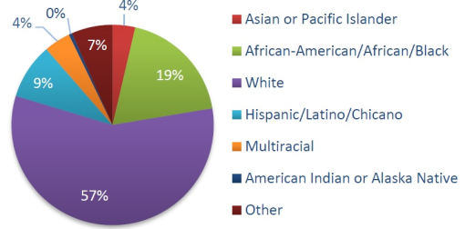
Figure 1: Figure title
Equations should be labeled as in Equation (1), with a number towards the right margin, if there is more than one equation.
(1)

SUBMISSION
You can fill in this template and then convert to Pdf format.
Your paper must be submitted using the Microsoft CMT submission page, which is announced on the official website.

REFERENCES
References should be listed as cited order in the text, using reference numbers and presented in the following format:
[1] Berawi, M.A., (2004). Quality Revolution: Leading the Innovation and Competitive Advantages. International Journal of Quality & Reliability Management, Volume 21(4), pp. 425–438 (Journal article, One author example)
[2] Harris, M. and Isler, Y. (2014). The GRO Green Roof Code. Final report of Green Roof Code of Best Practice for the UK 2014. Available online at: https://livingroofs.org/wp-content/uploads/2016/03/grocode2014.pdf, Accessed on 14 February 2017 (Website, two author example)
[3] Berawi, M.A. et al., (2024). Quality Revolution: Leading the Innovation and Competitive Advantages. International Conference on Next-Generation Engineering Technologies 2025, Alanya, Antalya, Turkey, pp. 25–26 (Conference articles, 3 or more authors example)

REVIEW PROCESS

Abstracts will be evaluated by the ISNET Scientific Committee. The abstract will be checked for both plagiarism and artificial intelligence writing tools. Authors of the accepted papers will be asked to register to attend the conference and present their work orally.

PUBLICATION
All registered and presented papers will appear in the ISNET proceedings.

The selected papers will be offered to sponsor journals, which are indexed in International Refereed Journals (Index Copernicus, DOAJ, etc.). In that case, authors should submit extended versions of their paper to the journal.

The papers submitted to the journal will go through a full review process, according to the journal regular process.

